Sensitivity analysis
Check how parameters affect pathogen resurgence (Hydra effect).
My approach to quantify Hydra effect here involves calculating the increase in pathogen abundance as its intrinsic mortality rate rises. Specifically, the abundance increase per unit increase in intrinsic mortality rate.
The slope was calculated from m = 0.001 to the time when hyperparasite extinction (calculate with invasion criteria). Therefore, the unit of hydra effect will be the pathogen abundance per intrinsic mortality rate.
似乎有兩個面相能夠討論：(1) 參數數值的改變，是否影響超寄生菌滅絕時的病原死亡率 (可透過 invasion criteria 確認)，影響程度有多大？ (2) 參數數值的變動，必影響病原死亡率提升時，族群數提升的幅度，而幅度變動會多大？
若參數數值的改變使超寄生菌滅絕時的病原死亡率提高，次致死量農藥 (sublethal dose pesticide) 的施用對於田間作物產量的影響會降低。假設施藥者原先施藥可使病原死亡率達 0.056，使超寄生菌死亡，參數數值改變後，超寄生菌需病原死亡率達 0.058 時方能使超寄生菌滅絕，則有助於降低植物產量急劇下降。
需要再施加多少農藥才能使植物產量恢復至未施用農藥的情況？
- 看初始植物產量如何。

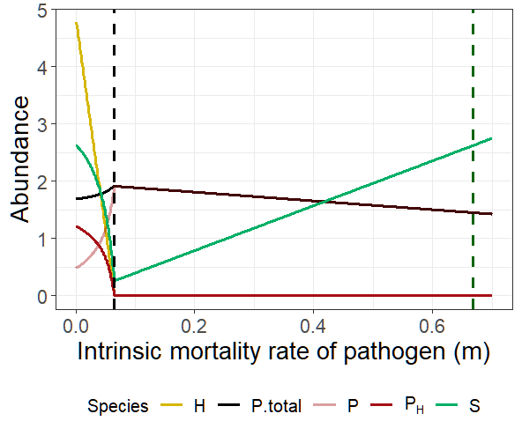

parms = list(
r = 1, K = 10,
a1 = 0.51, psi1 = 0.8, e1 = 0.5,
b1 = 0.42, e1H = 0.5,
o1 = 0.8, h1 = 1, c1 = 0.9, d = 0.02)
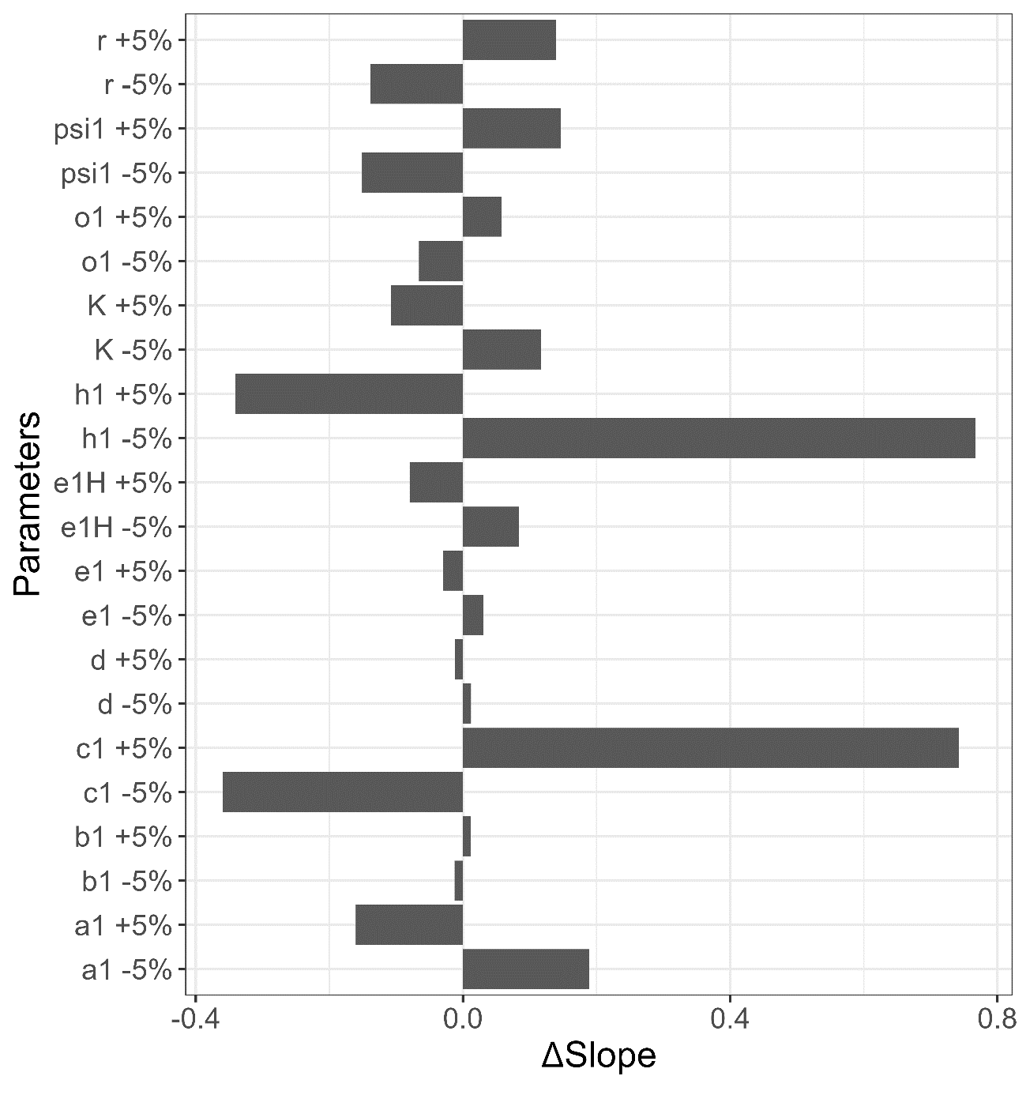
Most results indicate that the slope become shallow when pathogen can persist more hyperparasite.
For example, when K increase, now the pathogen can consume more plants and, therefore, can contribute more individuals to hyperparasites. The top down effect that hyperparasite exerts on pathogen is increases. As a result, an increase in pathogen mortality eventually weaken the hydra effect and make the slope shallow.

It is expected that an increase in r will get the same outcome of an increase in K, i.e., getting a shallower slope, due to the fact that both these two factors promote plant growth. Nevertheless, an increase in r makes the slope steeper. Although the pathogens total equilibrium abundance increases, it does not decrease the slope (pathogen abundance that increase per its mortality rate).
We can conclude that the slope cannot fully represent the Hydra effect.

An increase in other parameters, e.g., $h,e_{H},e, d, α$, can persist more hyperparasite, so it is reasonable that an increase in these parameters can make the slope shallow. Although $β and ω$ seems to increase the persistence of hyperparasite, these two parameters harm the pathogen directly, so as the mortality rate increase, the pathogen abundance increases more since it can persist less hyperparasite, and release more pathogens.

If $ψ$ increases, the Hydra effect will be strengthened.
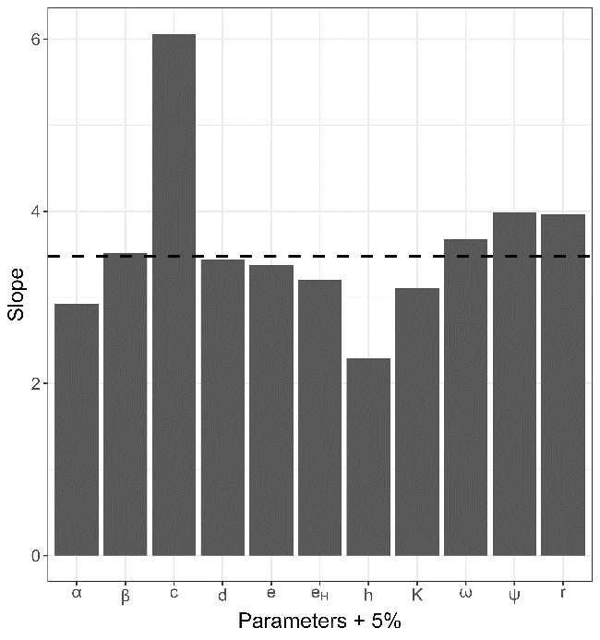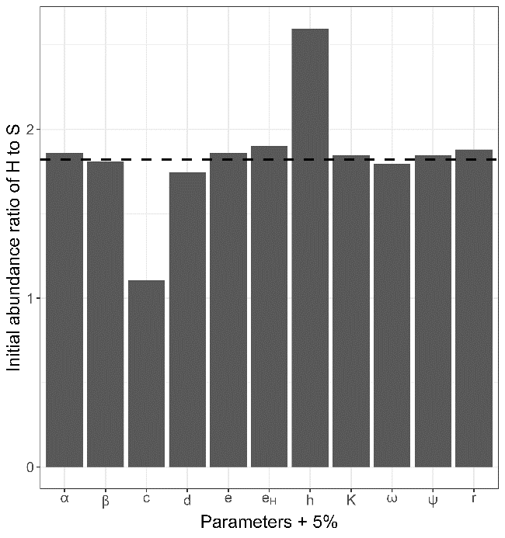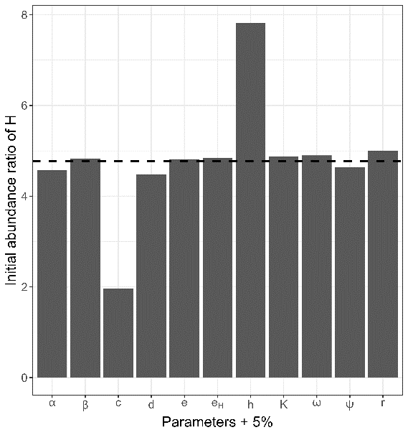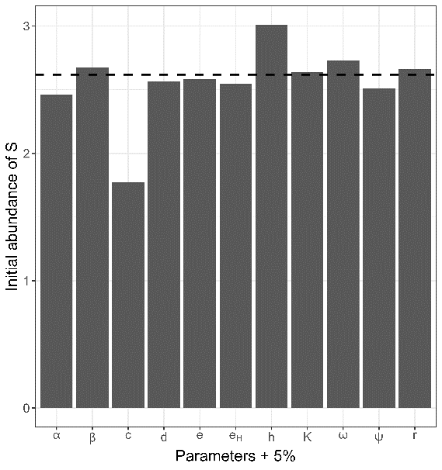
From the bar plot, we know that the c and h is most sensitive parameter.
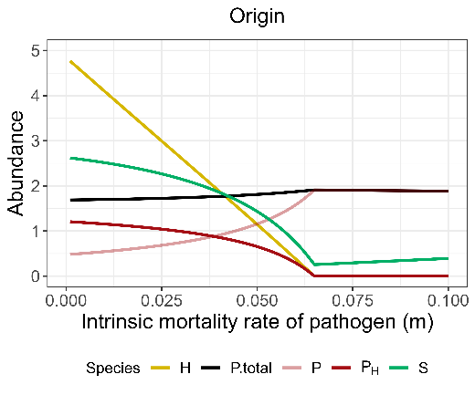
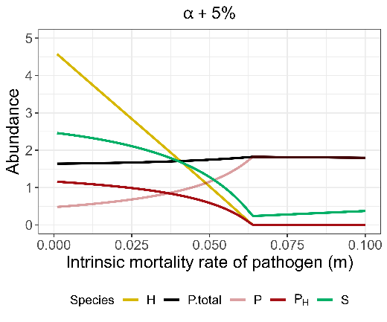

When $α$ increases, the pathogens consume more hosts. I assumed that pathogens contribute more to the hyperparasite, and strengthen the top-down effect that hyperparasites exert on pathogens. Such an effect may reduce the Hydra effect that induced by increasing in pathogen mortality. Although results show that the abundance of both hyperparasite and pathogen are decreased compared to the original parameter sets, the ratio of H to S is higher than origin, which may indicate that the host that pathogen consume are not all contribute to the hyperparasite.

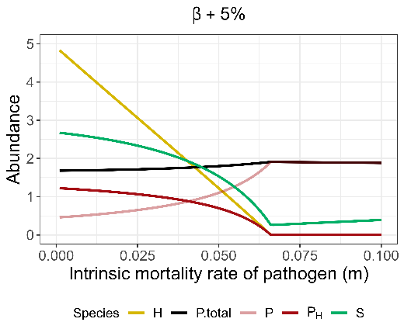
beta

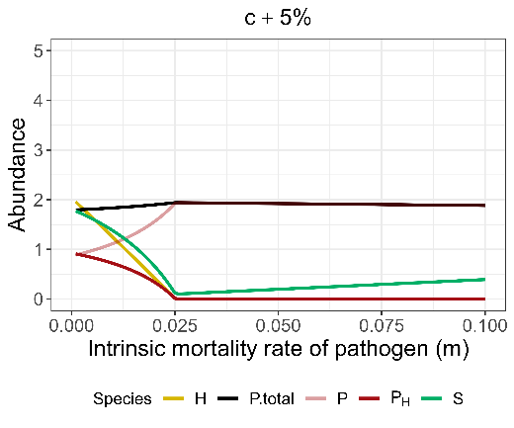
c
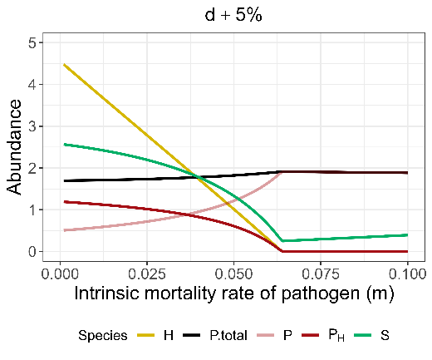
d
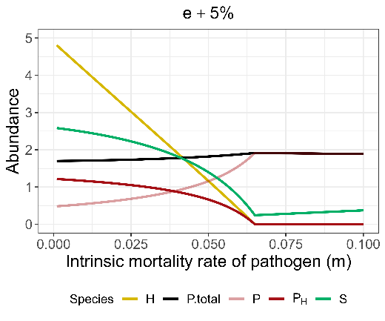
e
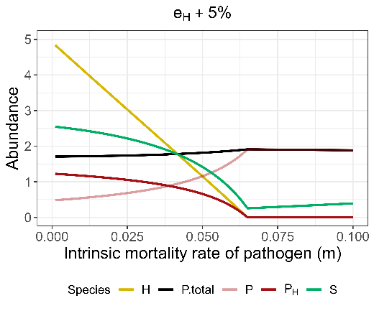
$$e_{H}$$
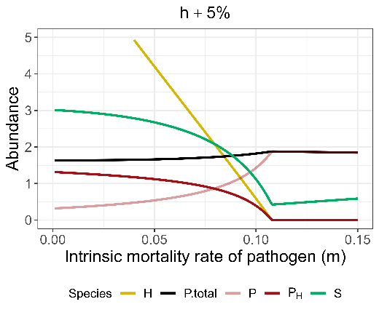
h
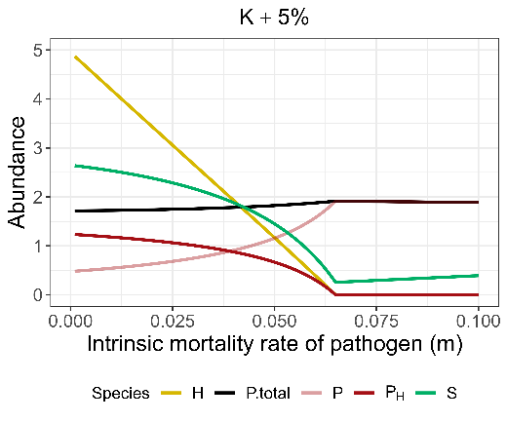
K
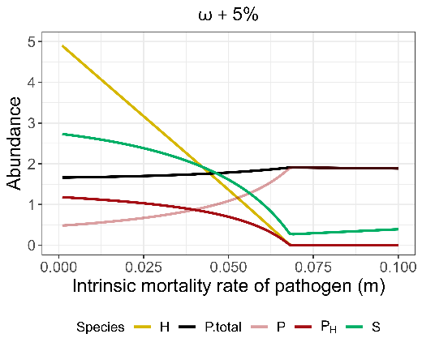
$$ω$$
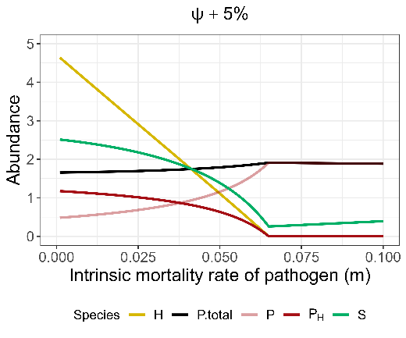
$$ψ$$
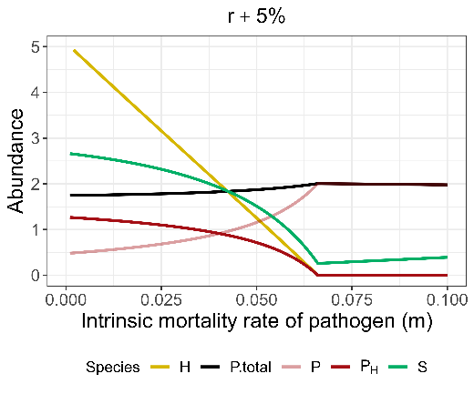
r

